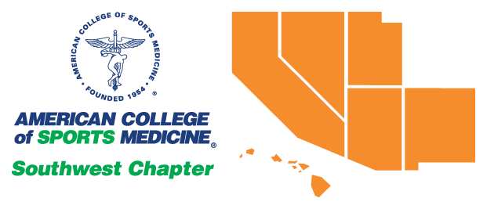
FRIDAY OCTOBER 29, 2021
Event | Time | Speaker and Topic | Location
Registration | 7:30 a.m.-5:00 p.m.
Demonstration/Workshop | 8:00-9:00 a.m. | Using Ultrasound to Measure Muscle Characteristics and Blood Flow: Demonstrations and Hands-On Experience  Wayne Johnson, PhD  Pat Vehrs, PhD, FACSM | Emerald Bay I & II
Demonstration/Workshop | 8:00-9:00 a.m. | Exercise is Medicine - On Campus: Road to Gold and Preparation for Community Engagement  Steven Loy, PhD, FACSM  Jason Ng, PhD | Emerald Bay III
General Session  DB Dill Lecture 1 | 9:15-10:45 A.M. | Weight Loss Disparities among Black and White Women: Twenty Years of Clinic Partnerships, Research, Recruitment, Enrollment, Randomization, and Outcomes  NiCole R. Keith, PhD, FACSM | Pacific Ballroom III & IV
Undergraduate Student Research Competition | 11:00 a.m.-12:30 p.m. | Moderator: James Navalta, PhD | Emerald Bay
Symposium 1 | 11:00 a.m.-12:30 p.m. | Nutrition in the MLB and NBA: Energy Needs, Challenges, and Myths  Becci Twombley, RDN | Pacific III
Symposium 2 | 11:00 a.m.-12:30 p.m. | Do We Know Squat? Perspectives from Biomechanics and Physiology  Sean P. Flanagan, PhD  Jill L. McNitt-Gray, PhD | Pacific IV
LUNCH | 12:30-1:45 p.m. | See Guidebook App or website for nearby restaurants
Graduate Student Research Competition | 1:45-3:15 p.m. | Moderator: Jenevieve L. Roper, PhD | Emerald Bay
Symposium 1 | 1:45-3:15 p.m. | Lessons Learned About Fasting and Meal Timing: Why Not Eating Might Be Beneficial and What Behaviors Can Make Fasting Behavior More Sustainable  Bruce W. Bailey, PhD, FTOS, FACSM  Landon Deru, MS, MBA, ACT | Pacific III
Symposium 2 | 1:45-3:15 p.m. | Training, Fitness, and Injuries  for Tactical Operators  Karen Kelly, PhD  Robert Lockie, PhD | Pacific IV
General Session  DB Dill Lecture 2 | 3:30-5:00 p.m. | ATP Usage in a World Class Marathon:  An Integrative Topic  L. Bruce Gladden, PhD | Pacific III & IV
Poster Session 1 | 5:00-7:00 p.m. | Pacific I & II
JEOPARDY | 7:00-8:30 p.m. | Moderators  Matt Lee, Ph.D.  James Navalta, Ph.D. | Pacific III & IV

SATURDAY OCTOBER 30, 2021
Event | Time | Speaker and Topic | Location
Registration | 7:30 a.m.-12:30 p.m.
Symposium 1 | 8:00-9:00 a.m. | Leadership in Sport, Science,  and Academics  Timothy P. White, PhD, FACSM | Pacific III
Symposium 2 | 8:00-9:00 a.m. | Heart Failure and Transplantation:  From the Personal Perspective of an Exercise Physiologist  Fred W. Kolkhorst, PhD, FACSM | Pacific IV
General Session  Founder’s Lecture | 9:15-10:45 a.m. | Designing and Implementing Pediatric Physical Activity Interventions  with Equity in Mind  Rebecca Hasson, PhD, FACSM | Pacific III & IV
Symposium 1 | 11:00 a.m.-12:30 p.m. | Anaerobic Threshold 50+  Years of Controversy  George A. Brooks, PhD, FACSM  L. Bruce Gladden, PhD, FACSM  Michael C. Hogan, PhD, FACSM  Harry B. Rossiter, PhD, FACSM | Pacific III
Symposium 2 | 11:00 a.m.-12:30 p.m. | 7 Summits:  Tales from the Top(s) of the World  Dale Wagner, PhD, FACSM | Pacific IV
Poster Session 2 | 12:30-2:30 p.m. |  | Pacific I & II

