Stephen Seiler

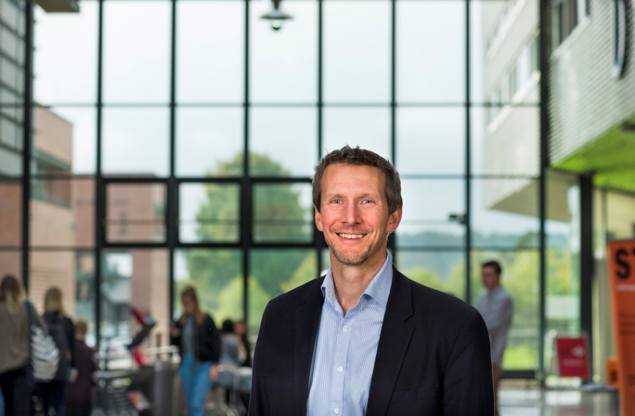

After growing up in the US and earning his doctoral degree from the University of Texas at Austin, Stephen Seiler PhD, has lived and worked in Norway for 25 years as a university teacher, researcher, and leader. He is past Vice-Rector for Research and Innovation and past Dean of the Faculty of Health and Sport Sciences at the University of Agder in Kristiansand, Norway. Currently, Dr. Seiler is Professor in Sport Science at the same institution. While anchored in an academic environment, Seiler has over the years served as research consultant and scientific advisor for a research foundation, sports teams, a regional hospital and the Norwegian Olympic Federation. From 2014 to 2019, Professor Seiler was Executive Board member of the European College of Sport Science, where he founded the Elite Sport Performance Special Interest Group in 2014. Seiler current consults the Uno-X Professional Cycling Team in Norway.

Seiler has become internationally recognized for his research publications and lectures related to the organization of endurance training and intensity distribution. This work has included both descriptive and experimental approaches, investigating cyclists, rowers, XC skiers, orienteers, and distance runners. His work has influenced and catalyzed international research around training intensity distribution and the “polarized training model”. Most recently, he has developed crowd-sourced research approaches that enable endurance athletes globally to contribute to research studies linking science and practice. Seiler has published ~100 peer reviewed publications, written over 100 popular science articles and given over 100 invited lectures related to exercise physiology and the training process across Europe, the United States, China, South Africa, Brazil and Australia. He is also a founding editorial board member of the International Journal of Sport Physiology and Performance.

