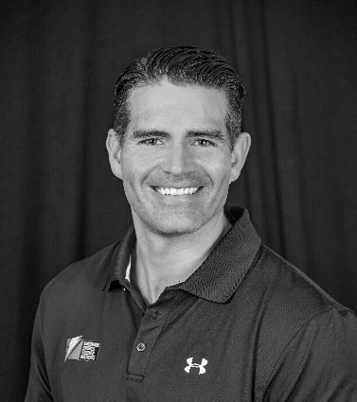

KEVIN LUHRS MS, RD, CSCS
Associate Principal Scientist

RESPONSIBILITIES:
Lead the GSSI Athlete Service Team and support for GSSI Athlete Performance Testing at GSSI IMGA

GSSI TEAMMATE SINCE:
2019

AREA OF EXPERTISE:
Sports Nutrition, Strength & Conditioning, Body Composition, Athlete Education

EDUCATION:
BS University of Nebraska (Nutrition Science and Dietetics), MS Concordia University-Chicago (Applied Exercise Science), currently enrolled PhD Concordia University Chicago (Health and Human Performance)

ATHLETIC BACKGROUND:
Kevin played college football and also played high school football, basketball, and track & field. After college, Kevin participated in bodybuilding, powerlifting, sprint triathlons, and marathons and currently strength trains recreationally.
SCIENTIFIC BACKGROUND:
Kevin is an Associate Principal Scientist at the GSSI satellite lab at IMG Academy in Bradenton, FL. His primary responsibility includes leading the GSSI Athlete Service Team. Kevin earned his BS at the University of Nebraska in Nutrition Science and Dietetics while playing football as a defensive lineman for the Cornhuskers. He then went on to undergo his Dietetic Internship through the Baptist Health System in San Antonio, TX before becoming a Registered Dietitian in 2009. Shortly after going back to Nebraska to work as a volunteer Sports RD for football, Kevin became the Team Sports Dietitian and Assistant Strength Coach for the Tampa Bay Buccaneers in 2010. He worked closely with the players, coaches, and support staff while pioneering the Buccaneer’s first Sport Nutrition Program over 9 seasons. With the Bucs, his duties included the coordination of all meals and snacks for all players at home and on the road, instructing players what to eat based on their goals and timing of competition for optimal performance and recovery, and the heavy involvement in hydration strategies. A big focus of Kevin’s research during this time was the possible correlation of body composition on player risk of injury. He also served as one of the Senior Leaders for the NFL RDs and worked diligently with the NFL and NFLPA on Collective Bargaining Agreement (CBA) amendments. Also during this time, he earned his MS in Applied Exercise Science from Concordia University Chicago. Outside of work life, Kevin likes to spend time with his wife, go to movies, travel, and lift weights.

