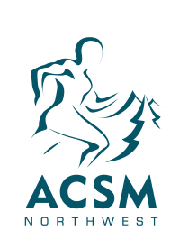
ACSM Northwest Service Awards
Call for Nominations

The ACSM Northwest Service Awards recognize members who have made outstanding contributions (service and/or leadership) to the Chapter. The awards are described below. Nominations can be made by completing the nomination form and emailing the form to president19@acsmnorthwest.org by September 23, 2019 at 5pm PST. Award winners will be recognized at the Chapter’s Annual Meeting.

Service Award
The ACSM Northwest Service Award is an honor for members who have provided exceptional service and/or leadership to the Chapter.

Criteria for nomination:
- Nominee is a current member in good standing of the Chapter.
- Nominee has provided outstanding service and/or leadership to the Chapter for at least 3 years, in multiple capacities (see examples below).

Lifetime Membership Award
The ACSM Northwest Lifetime Membership Award recognizes a lifetime commitment of outstanding leadership and service to the Chapter.

Criteria for nomination:
- Nominee is a current member in good standing of the Chapter or is an officially retired member of the Chapter who was in good standing at the time of retirement.
- Nominee has provided outstanding service and/or leadership to the Chapter for at least 10 years, in multiple capacities (see examples below).
- Nominee has been an outstanding professional who has been in the field for at least 10 years, during which a strong commitment has been demonstrated to the Chapter and field of Sports Medicine.

Examples of leadership and service to the Chapter:
- Executive Board Member
- Abstract reviewer
- Symposium reviewer
- Conference Director
- Conference Committee Volunteer
  - Obtain sponsors
  - Secure presenters
- Conference volunteer
  - Moderator
  - Poster judge
  - Oral presentation judge
  - Thematic poster judge
  - Student Bowl volunteer
  - Registration desk volunteer
  - Pre-conference volunteer for set up
- Providing website content
- Providing Facebook content

