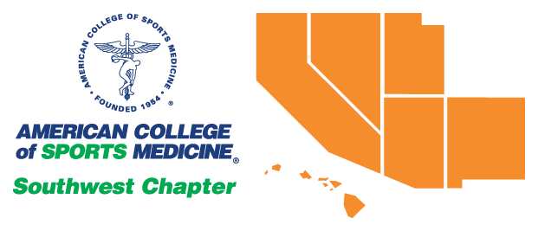

SWACSM 2022
Abstract Submission Information
SWACSM General Abstract Submissions &
SWACSM Expanded Abstracts for the Student Research Award Competition

Expanded Abstracts for the Student Research Award Competition Due Friday, September 16, 2022, 5:00 pm, PDT

General Abstracts Due Friday, September 23, 2022, 5:00pm, PDT

Abstract Submission Link: https://digitalcommons.wku.edu/ijesab/
SWACSM 2022 Abstract Submission Instructions
SWACSM Annual Meeting and Conference, starting Friday, October 28, 2022.
All members and those joining the Southwest Chapter of the American College of Sports Medicine (SWACSM) are invited to submit abstracts for presentations, either as a general poster presentation or in our student research award competition.
Please follow the general and/or student research award specific instructions for submission.

General Abstract Submission Instructions
- All abstract submissions are required in electronic format and all presentations (poster or oral). The student research award competition question and answer (Q&A) sessions are scheduled for Friday, October 28, 2022. See below for student award competition specifics.
- Each individual is permitted to be first author on only one abstract, but may co-author several abstracts.
- The first author is considered a presenter and must present the abstract at the meeting.
- At least one of the authors must be a member of the SWACSM.
- If one of the authors is a Fellow of the American College of Sports Medicine (ACSM), the letters FACSM should follow their name.
- All abstracts (maximum 2000 characters without spaces) will be published in the program as submitted. Minimum acceptable type size will be 11 cpi and no larger than 12 cpi. Arial type font is preferred. Please check for spelling errors prior to submission.
- Abstracts should not have been published previously in any other printed or electronic format as abstracts will be published in the International Journal of Exercise Science. Publishing will be delayed so authors can also submit their abstracts to national ACSM if they so choose.
- Abstract subheadings should follow ACSM requirements; purpose, methods, results, and conclusions.
- For students, presenting at SWACSM does not preclude submitting the same abstract for presentation at an ACSM national meeting.
- Keep a copy of the abstract for your records.
- Following submission of an abstract, an electronic email confirmation will be sent to the applicant and co-authors (if co-author emails are provided). Email notification of acceptance and presentation information will be sent following submission from our SWACSM Abstracts and Awards members, Dr. Jeff Bernard (jbernard1@csustan.edu), Sarah Camhi (scamhi2@usfca.edu), or Dr. James Navalta (james.navalta@unlv.edu). If you do not receive the email notification, check that you included the correct email address free of spelling errors or check your junk mail or SPAM folders. You can contact the SWACSM Abstracts and Awards members, if you believe you did not receive an email confirmation, see details below.
- In the Cover Page Footnote dialogue box of the submission you will have the option of choosing a preferred presentation day (Friday or Saturday). Suggestions will be taken into consideration but the presentation day cannot be guaranteed.
- All general poster presenters are expected to create a visual poster. See example below.

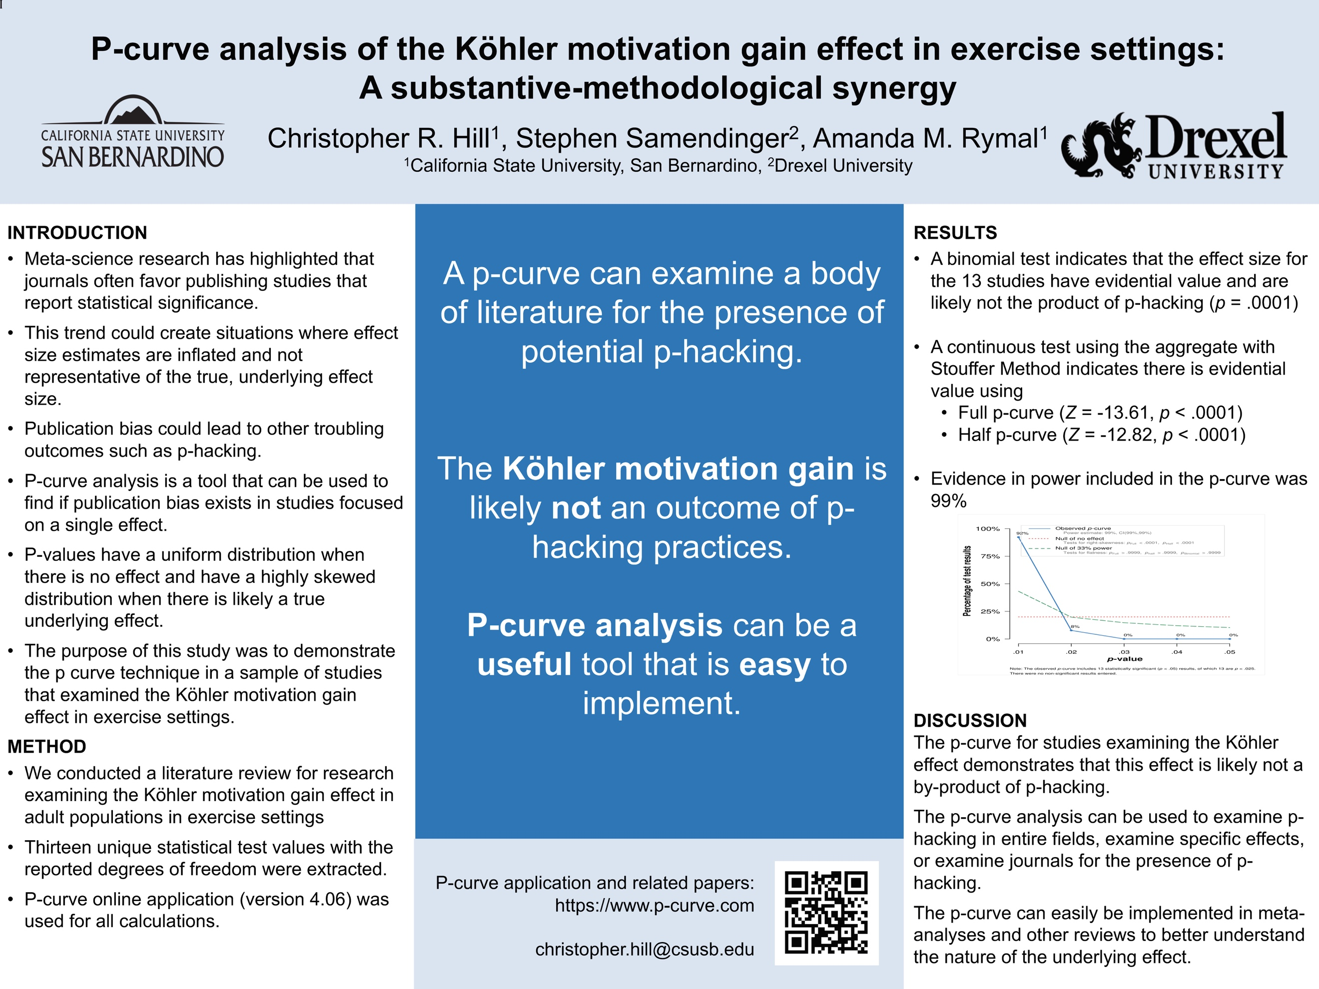

Student Research Award Competition Specific Instructions
- If you are submitting your expanded abstract for the student research award competition, you must indicate this in the electronic submission form due Friday, September 16, 2022 AND you must submit both a brief and an expanded abstract for consideration by the deadline Friday, September 16, 2022.
- All expanded abstracts will undergo a blind review by three experts in the field for the competition while the brief abstract will be included in the program.
- The expanded abstract is limited to 5 pages (not counting references) and must be double spaced following the same font requirements as the brief abstract (abstract requirements are listed under the general instructions).
- The expanded abstract should provide the study's background, purpose, design/methods, results (including optional tables and figures), discussion and conclusions.
- If the expanded abstract does not follow the above format, it will be returned to the first author for revisions. Revisions must be submitted no later Friday, September 23, 2022 for continued consideration in the competition.
- Be sure to include the name of your advisor/mentor and his/her email address. An email message may be sent to your advisor/mentor verifying your student status and to confirm the expanded abstract is appropriate for presentation at the SWACSM Annual Meeting and Conference.
- All work reported in the expanded abstract must have been conducted while you were a registered student at an institution in the Southwest Region and the abstract may have multiple authors/investigators although only one individual is to present.
- Abstracts should not have been published previously in any other printed or electronic format.
- Five student presenter finalists for each level, undergraduate and graduate, will be asked to present an oral presentation on Friday, October 28, 2022.
- All expanded abstracts NOT selected for the competition will be asked to present as a general poster presentation.
- The Undergraduate Student Research Award Competition is scheduled for 11am-12:30pm on Friday, October 28, 2022.
- The Graduate Student Research Award Competition is scheduled for 1:45pm-3:15pm on Friday, October 28, 2022.
- Following review of the finalists by competition judges, winners of each competition will be announced in the General Session held on Saturday October 29, 2022 from 9:15am-10:45am.
- Additionally, one overall winner from the Undergraduate and Graduate Student Research Award Competition winners will be named and asked to represent the chapter at the ACSM National President’s Cup Competition.
All questions regarding the abstract submission or the student research award competition should be directed to:
Dr. Jeff Bernard, SWACSM Abstracts and Awards
Department of Kinesiology and Publich Heath Promotion, California State University, Stanislaus
Email: Jbernard1@csustan.edu
SWACSM Abstract – Please do not change any fonts, font sizing, or spacing!

This is My Abstract Title – notice appropriate uppercase

AUTHOR B. ONE, AUTHOR C. TWO, FACSM, & AUTHOR D. THREE First then Last name, all upper-case

Laboratory Name; Department; University; Location, STATE

Category: Undergraduate/Masters/Doctoral/Professional/Professional-in-Training (select one & delete others)

Advisor / Mentor: Last Name, First Name (email address) – do NOT hyperlink the email

ABSTRACT
Begin with a short sentence or two with background on the topic. Please include a PURPOSE: describing the intent of the study. METHODS: how the study was conducted. RESULTS: findings of the study should be here. CONCLUSION: Reference lists are not generally included. Please note the abstract headings (they must be included, bolded and uppercase). Do NOT change the justification (alignment), font type, font size, or spacing (general abstracts should be single-spaced, expanded abstracts should be double spaced).

All abstracts (maximum 2000 characters without spaces for general abstracts) will be published in the program as submitted. Expanded abstracts for the student research award competition is limited to 5 pages (not counting references) and must be double spaced following the same font requirements as the brief abstract.

Direct any questions about this process to Dr. Jeff Bernard (Jbernard1@csustan.edu) to ensure your abstract is formatted properly and submitted successfully.

Once finished, be sure to delete anything in red. Once the following is read, please delete as well:

This abstract has not been presented and will not be presented at any other conference, other than National ACSM. Abstract submission assumes study has been approved by an appropriate IRB.

Access the International Journal of Exercise Science Conference Proceedings site at: https://digitalcommons.wku.edu/ijesab

Click on “Submit Abstract” (left side menu)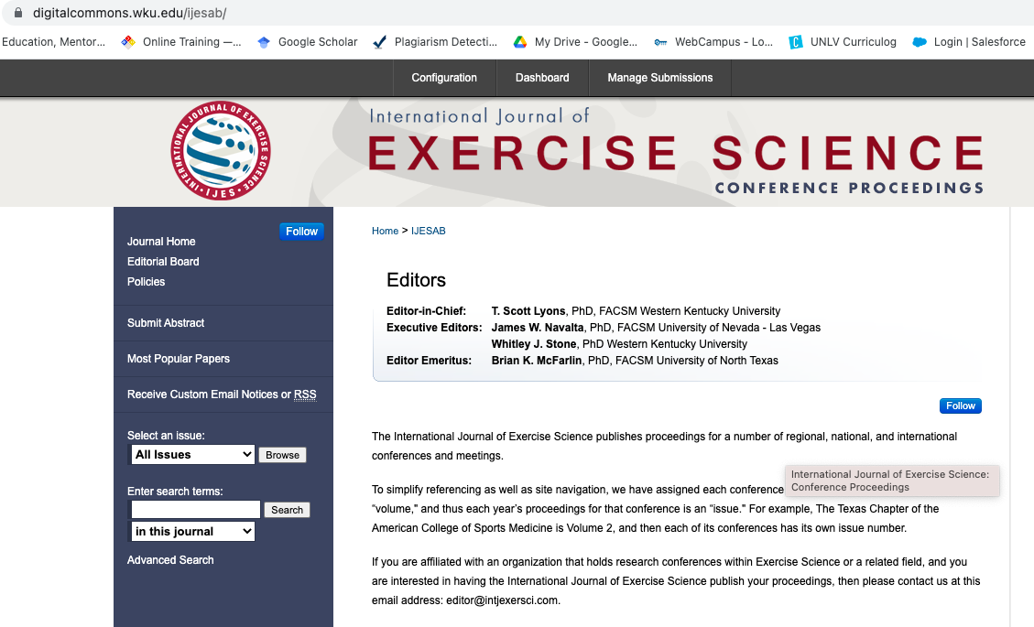

Have your title (in Title case), author emails, and SWACSM abstract template saved in a known location. Click “Continue”

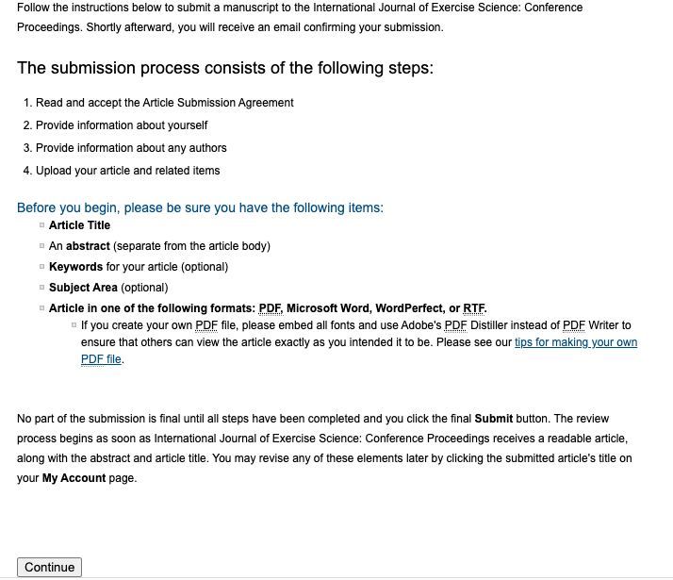
Read the Article Submission Agreement and click “Accept”
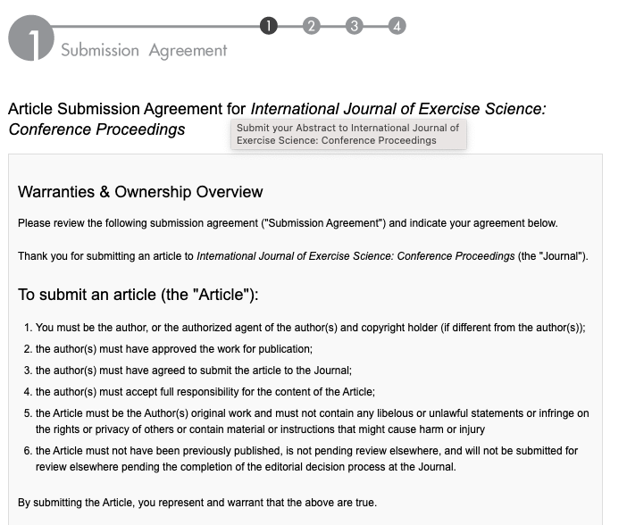
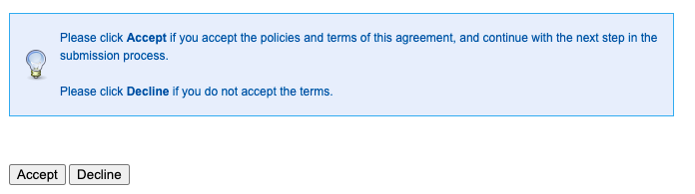

Enter your First/Given name, Last/Family name, and Institutional Affiliation.

**If you are a Fellow of the American College of Sports Medicine, enter FACSM in the suffix dialogue box.

Click “Continue”

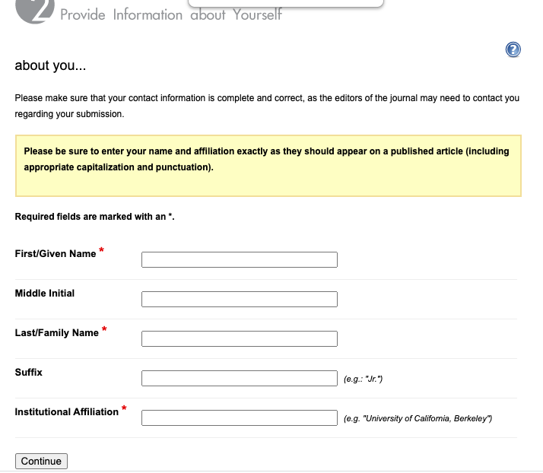

Click “Add author” to include coauthors.

Then add the required information and click “Add to list of authors”.
**If a coauthor is a Fellow of the American College of Sports Medicine, enter FACSM in the suffix dialogue box.

Repeat until all coauthors are included.

Then click “Continue”
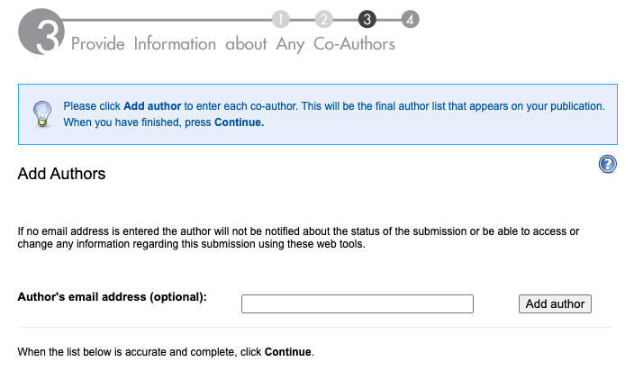

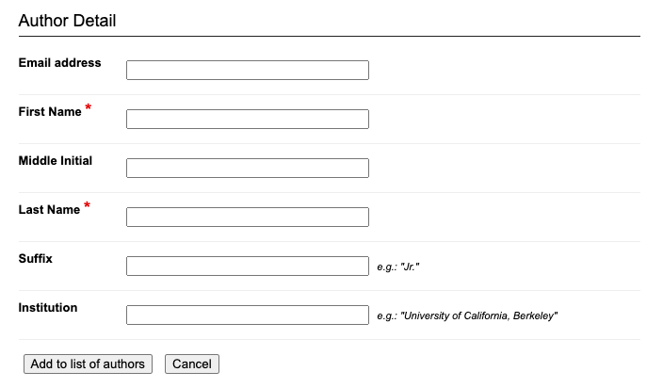

Enter the article title (it is not necessary to enter a short title, key words, or select a subject area)
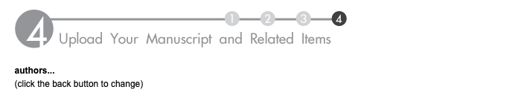

For submission type, select Southwest ACSM Abstract

**NOTE: If submitting for the student research competition, select either “Student Research Competition – Undergraduate” or “Student Research Competition – Graduate” (instead of Southwest ACSM Abstract)
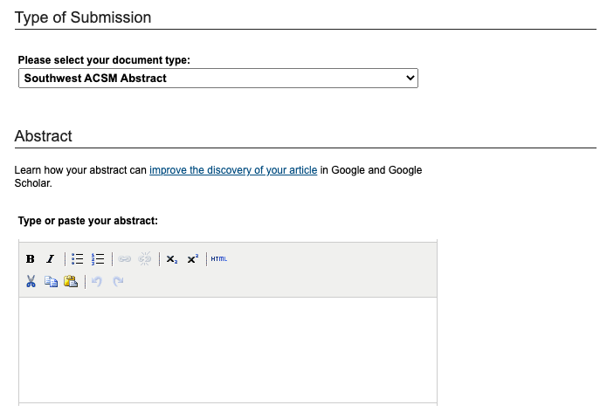
Paste your abstract into the Abstract dialogue box

In the Cover Page Footnote dialogue box, enter your preferred presentation date (Friday or Saturday)

Upload the template containing your SWACSM abstract using the Full Text of Submission radio button.
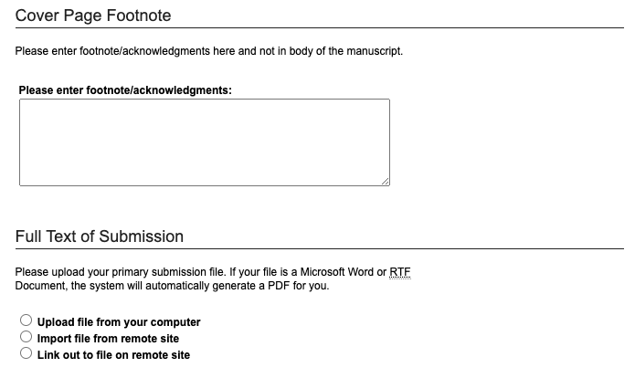
You do NOT need to include a cover letter
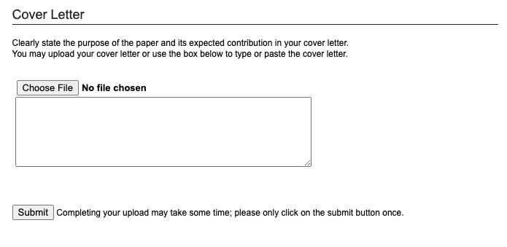
Finally, click “Submit” one time.
You will receive an email confirmation that your abstract has been submitted.

